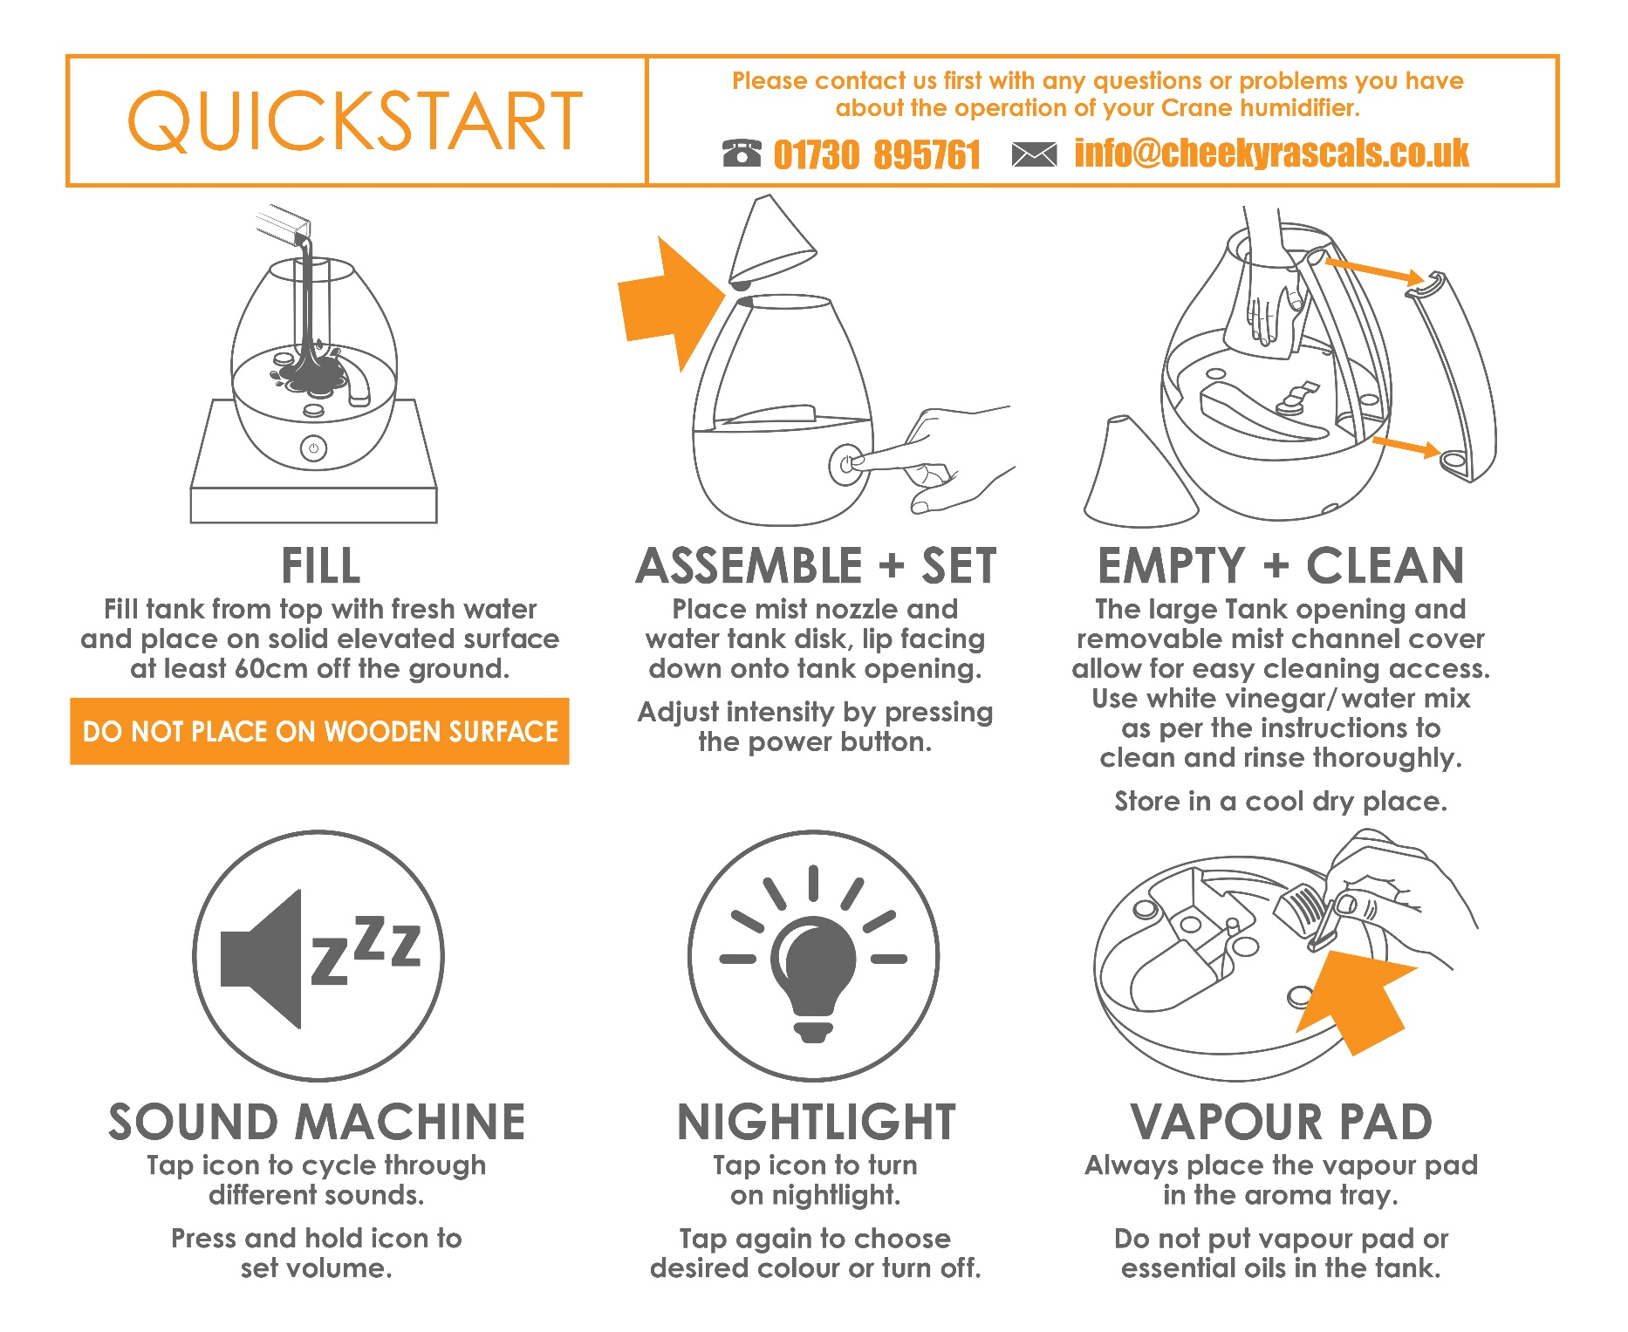

IMPORTANT: PLACE WATER LEVEL SENSOR FLOAT INTO BASE BEFORE USE

PLEASE READ INSTRUCTIONS!

DROP Top Fill Ultrasonic Cool Mist Humidifier

with Sound Machine
For all models of EE-5306 series
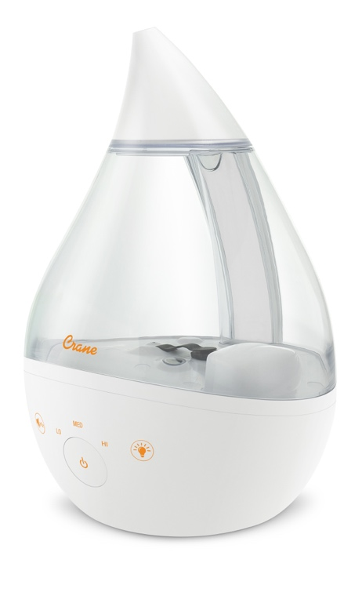

If you have any questions about the operation of your humidifier, please contact Customer Care.
Phone Number: 01730 895761
Email: info@cheekyrascals.co.uk

IMPORTANT: Read these instructions and keep for future reference.

SAVE YOUR DATED PROOF OF PURCHASE!

[ You will need this in case of warranty]

staple
tape
or paperclip
your
receipt
HERE

Table of Contents& Sustainability | P. 1
Safety Instructions | P. 2-3
List of Main Parts | P. 4
Technical Specifications, Assembly & Use | P. 5-6
Sound Machine, Nightlight Function, Aroma Tray | P. 7
Maintenance, Cleaning& Storing Your Humidifier | P. 8 -9
Customer Care &Trouble Shooting | P. 9
Warranty | P. 10
TABLE OF CONTENTS

CRANE & SUSTAINABILITY
Crane USA is dedicated to your environment both inside and outside your home. We know if cleaned and maintained properly, our products last for years helping to reduce unnecessary use of resources and emissions making new products.

The Crane manual you are holding is from recycled materials with no added finishes or harmful dyes. If the humidifier should no longer operate, please be sure to dispose of the unit in an environmentally friendly way by taking it to a public collection point.

PLEASE DO NOT PLACE BROKEN HUMIDIFIERS WITH YOUR REGULAR HOUSEHOLD WASTE.

Correct Disposal of this product. This marking indicates that this product should not be disposed with other household wastes. To prevent possible harm to the environment or human health from uncontrolled waste disposal, recycle it responsibly to promote the sustainable reuse of material resources.

IMPORTANT SAFETY INSTRUCTIONS
WARNING! READ AND SAVE THESE INSTRUCTIONS AND KEEP FOR FUTURE REFERENCE. Failure to follow all of the instructions listed below may result in electric shock, fire and/or serious personal injury.

- It is advisable to carry filled Water Tank with two hands.
- ALWAYS secure water level sensor float into humidifier base before use.
- DO NOT operate outdoors. This humidifier is intended for indoor use only.
- Always have water in the Water Tank when operating the unit.
- Use only clean, cool tap water to fill the Water Tank (filtered or distilled water is recommended to avoid the buildup of limescale). DO NOT use hot water.
- Be sure that the Water Tank Disk and Mist Nozzle are placed securely on Water Tank. Always have the Water Tank Disk and Mist Nozzle in place while the unit is operating. Place the humidifier so the mist aims away from children, walls, furniture and electrical appliances.
- Use only a 100-240VAC outlet. Only use the AC Adaptor cord that came with the unit. ALWAYS plug and unplug unit with dry hands to avoid electric shock.
- Never operate the unit with a damaged cord or plug.
- Always place the unit on a smooth, flat, lint-free, non-metallic, non-wooden waterproof and level surface and position unit away from direct sunlight. Keep the cord away from heated surfaces and areas where it could be walked on or tripped over. Unplug the unit when not in use and whenever you clean or move the unit.
- Do not add medication or essential oils of any type into the Water Basin or Water Tank. ONLY use vapor pads or essential oils on an unscented pad in the Aroma Tray of this humidifier. Do not cover any openings on the unit or insert objects into any openings.
- The unit should not be left unattended in a closed room as the air could become saturated and leave condensation on walls or furniture. Leave room door partly open when humidifier is being operated.
- When cleaning humidifier base, keep water away from the Fan Vent. Turn off and unplug the humidifier to wipe the exterior (except the electrical controls) with a damp cloth. Humidifier requires regular cleaning. Please refer to the MAINTENANCE &CLEANING in this manual (pages 8-9).
- Do not tilt or tip the humidifier or attempt to empty or fill it while it is in operation.
- Do not use a detergent to clean any parts of the unit that contain water. Detergent film dissolved in the water supply can interfere with the output of the unit. Instead, always use white vinegar mixed with water to clean the humidifier.
GENERAL SAFETY INSTRUCTIONS
WARNING! Read and understand all instructions. Failure to follow all instructions listed below may result in electric shock, fire or serious personal injury. The warnings, cautions, and instructions discussed in this instruction manual cannot cover all possible conditions and situations that may occur. It must be understood by the user that common sense and caution are a factor which cannot be built into this product but must be supplied by the user.

THIS HUMIDIFIER IS NOT A TOY!

Do not let your child play with this humidifier. Serious injury and electrocution might
be possible. This humidifier has to be operated by an adult only. Children should be supervised to ensure that they do not play with the humidifier.

SAVE ALL INSTRUCTIONS FOR FUTURE REFERENCE!

CAUTION: A short Power Supply Cord is provided to reduce the risk of personal injury resulting from becoming entangled in or tripping over a longer cord. Extension cords are available from local hardware stores and may be used if care is exercised in their use. If an extension cord is required, special care and caution is necessary. Also the extension cord must be (1) marked with an electrical rating of 125 V and at least 13 A., 1625 W., and (2) the cord must be arranged so that it will not drape over the countertop or tabletop where it can be pulled on by children, be a strangulation hazard, or accidently tripped over.

ELECTRIC POWER
If the electric circuit is overloaded by other appliances, your humidifier and/or appliances may not operate properly. The humidifier should be operated on a separate electrical circuit from other operating appliances.

AC ADAPTOR
The AC/DC Adaptor included with the Crane Drop Cool Mist Humidifier with Sound Machine is 100-240V 50/60 Hz and can be used worldwide. However, in some countries you may need to use an outlet adaptor.

SAFETY WARNING
Although your humidifier is easy to operate, for your safety, the below warnings must be followed:
- Do not place the humidifier near a heat source.
- Never leave the humidifier unattended while connected to the electrical outlet.
- To avoid any accidents, never cover the Mist Nozzle when the humidifier is in operation.
- Use the humidifier on a smooth, flat, lint-free, non-metallic, waterproof, and level surface away from water.
- Do not unplug from the wall socket by pulling on the supply cord.
- The humidifier must be unplugged:
  - Before either filling or emptying the humidifier Base and/or Water Tank.
  - Before any cleaning or maintenance is performed.
  - After each use.
  - If it appears to be faulty.

THIS PRODUCT IS INTENDED FOR HOUSEHOLD USE ONLY.

LIST OF MAIN PARTS
IMPORTANT: Water level sensor must always be secure in the base of the humidifier!
6
Fig. 1 (Humidifier Base)  - Nebulizer  - Fan Outlet  - LED Light  - Aroma Tray for vapor pads  - Water Level Sensor Float  - Power Button and Indicator Light  - Nightlight Color Changing Control (optional)  - Sound Machine Control (optional)  - Plug Port | 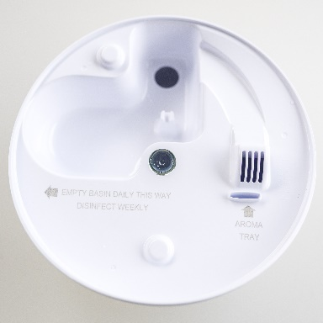  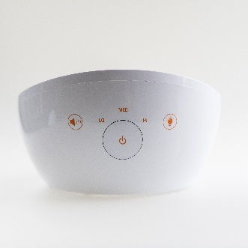  3  2  8  6  7  4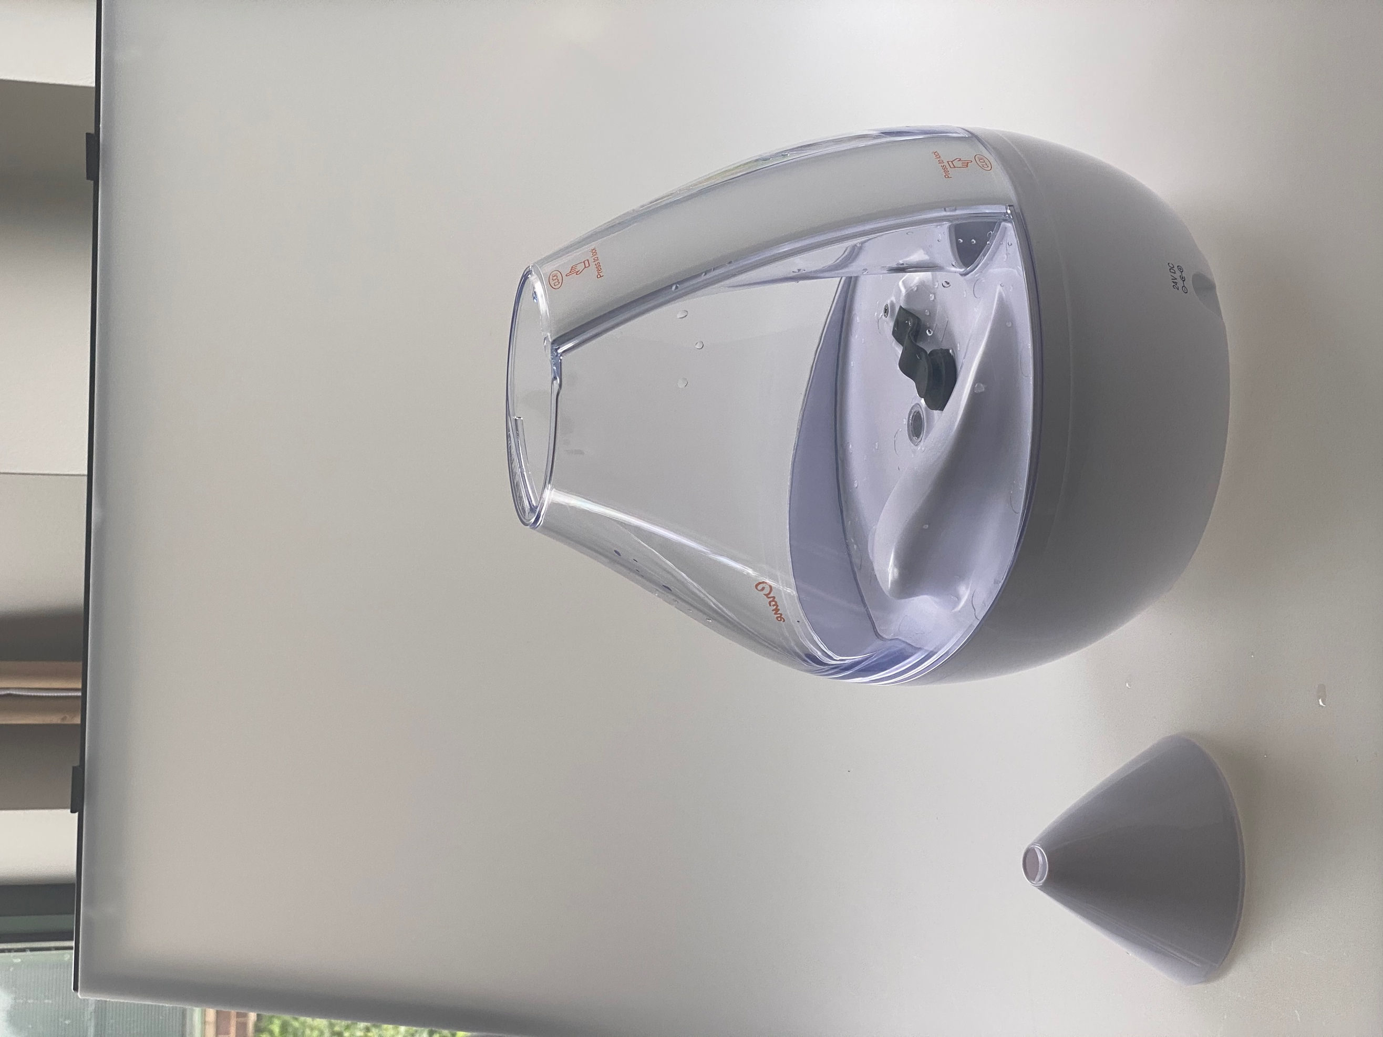  1  5  9
Fig. 2 ( Water Tank)  - Mist Channel Cover (removable for easy cleaning)  - Silicone Tank Valve (Inside tank)  - Water Fill Opening (top of tank) | 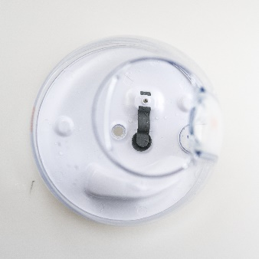  11  12  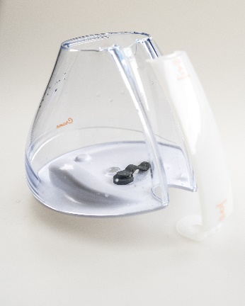  1000
Fig. 3  - Water Tank Disk(with lip)  - Mist Nozzle  - Detachable AC Adaptor Cord  - Vapor Pad (1)- For aroma tray.  *Vapor Pads available on Crane website | 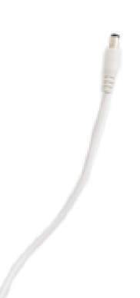  15  14  13  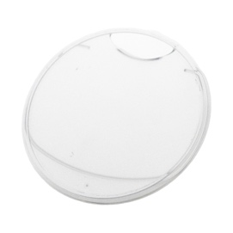  16

TECHNICAL SPECIFICATIONS

Adaptor Voltage Rating | Input: 100V -240VAC, Output: 24VDC 1.0A
Humidifier Voltage Rating | 24 VDC, 1.0A
Frequency | 60Hz
Water Tank Capacity | Approx. 1 Gallon / 3.8 litre
Run Time Per Tank | Up to 24 hours
Humidifying Capacity | Up to 500 sq. ft. / 46 m²
Noise Level | < 37 decibels from 90cm/3 ft away

BEFORE EACH USE:

CHECK HUMIDIFIER PLACEMENT:
Place the Humidifier on an elevated, non-metallic, lint-free, waterproof, level surface at least 65 cm/2 feet above the floor.

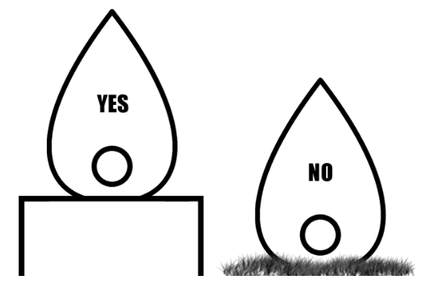
• DO NOT PLACE ON CARPET OR TOWEL. The fan vent is located on the bottom of the humidifier base. The fan vent MUST NOT be obstructed.

• DO NOT PLACE ON WOODEN SURFACE or near furniture that can be damaged by too much moisture.

CHECK WATER LEVEL SENSOR:
Make sure the Water Level Sensor Float is secured properly and not obstructed.
(Page 4 – Fig. 1, Part 5)

CAUTION
• DO NOT attempt to operate the humidifier without water in the Water Tank.
• DO NOT plug or unplug the Power Cord with wet hands as electric shock could occur.

ASSEMBLY & USE

Use only clean, cool tap water (filtered or distilled water is recommended). ALWAYS make sure detachable cord is attached to base. ALWAYS ensure the water level sensor float is secure in the base.

- WATER LEVEL SENSOR FLOAT (Page 4, Fig1 #5)- Remove float from plastic bag and place into the base as shown in figure 1. IMPORTANT: water level sensor must be placed securely in the base (see Troubleshooting).
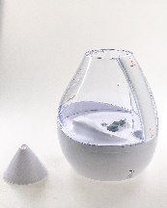
- WATER TANK (Page 4, Fig 2)- Place water tank onto the humidifier base ensuring the Crane Logo lines up with the Power Button for proper water tank placement.
Fill water into the water fill opening. As shown WATER
in figure 2.

ALWAYS HOLD WATER TANK WITH TWO HANDS WHEN FULL.
DO NOT fill water all the way to the rim.
DO NOT use hot water.
DO NOT add any medication, essential oils, (Fig. 1 (Fig. 2)
vapor pads or salt into the tank.

NOTE: Filtered or distilled water is recommended to avoid buildup of limescale if tap water is too hard

- MIST CHANNEL COVER (page 4, Fig. 2 #10)-Secure the mist channel cover onto the water tank. You will hear an audible click on top and bottom of the mist channel cover to secure placement.

- WATER TANK DISK (page 4, Fig. 3 #13)-Place the Water Tank Disk, with disk lip down, securely onto water tank opening.

- MIST NOZZLE (page 4, Fig. 3 #14) -Place the mist nozzle securely onto the water tank disk. Direct the mist output by turning the mist nozzle to the direction you want the mist to emit.
Note: Do not attempt to move the humidifier while full Water Tank is placed on the Humidifier Base. Doing so may cause leakage of water and/or Humidifier Base to overfill.

- CONNECT AC ADAPTOR CORD into the Plug Port (page 4, Fig. 3 #15). Plug the power cord into a wall socket and turn on the unit by using the Power Button. PRESS POWER BUTTON (page 4, Fig. 1 #6) 1x for low, 2x for medium, 3x for high and 4x to power off.

Note: The Power Indicator Light will illuminate in green indicating that the unit is on.

IMPORTANT: After 20 seconds, the indicator light will turn off but product will continue to run. This feature allows the humidifier to be on without a visible illuminating light.

SET THE CORRECT HUMIDITY OUTPUT: Adjust the mist output so the mist rises up to be absorbed by the room air. If mist drops quickly, use the lower output setting so the mist is rising up.

- AUTOSHUT OFF When the humidifier runs out of water, the Power Indicator Light will turn red and the mist output will stop. This is a safety feature to prevent the humidifier from possibly overheating and damaging the Nebulizer. Turn the humidifier off and unplug the unit before removing and refilling the water tank.

SOUND MACHINE: Lightly Tap
Press 1x for White Noise, 2x for Rain Sound, 3x for Ocean Sound and 4x to power off.

To Adjust Volume of Sound: Press& holdand volume will cycle between Low to High volume. Release button to set desired volume.

NOTE: When the sound is turned off and then turned back on, the volume will be at the same level.
NIGHTLIGHT FUNCTION: Touch
Press 1 x for steady Red Sleep Support light. Press 2 x light color changes every 10 seconds. Press 3 x to set current light color. Press 4th time to turn the light OFF.

Red Sleep Support Light: Optional steady Red Light may help with better sleep. Red light doesn’t act as a stimulant. Its low color temperature, far lower than regular sunlight, has a soothing effect on the body for a good night’s sleep. Using red light in the evenings may help your body transition into its sleep cycle more naturally

AROMA TRAY: Remove the water tank. Place the sample Crane Vapor Pad (HS-1950/L) into the aroma tray or add essential oils to an unscented pad and the place into the aroma tray as desired. Replace the water tank before running the humidifier. ALWAYS ensure the water level sensor float is placed securely in the base.

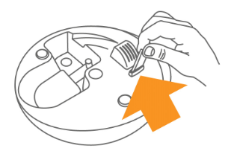
Only use vapor pad in the aroma tray.
Do not put vapor pad or essential oils in Water tank

VAPOR PAD PRECAUTION

- The sample Calm and Sleep vapour pad supplied with this humidifier can be used with babies and children of all ages, please refer to detailed instructions on the Vapour Pads pack. Some essential oils provoke respiratory and allergic reactions in babies and young children. If providing your own essential oils/ vapour pads, please check they are suitable before use. If in any doubt, get advice from a qualified healthcare professional.'
- Crane Calm & Sleep Vapour Pads are suitable for children between 10-22 lbs (4.5 kg) do not use more than 2 pads in a 24 hour period.

A NOTE ABOUT HUMIDITY
- To reduce excessive humidity or condensation, especially in small rooms, leave the room door open and adjust mist intensity to the low output setting.
- Too much humidity in the room may allow moisture to accumulate on surfaces where bacteria and fungi can grow. Moisture that gathers may also damage furniture and walls, especially wallpaper.

MAINTENANCE & CLEANING

Cleaning and disinfecting on a regular basis is very important for maintaining the performance of your humidifier. NEVER IMMERSE HUMIDIFIER BASE IN WATER.

IMPORTANT: Water left in the tank or humidifier base when not in use may result in buildup of mineral deposits and bacteria which may inhibit the output efficiency as well as void the warranty. If water remains in the Water Tank for more than a day or two, bacterial growth is possible.

DAILY MAINTENANCE

- Turn off, unplug from outlet and empty water from tank &humidifier base daily (Pour the water away from fan outlet).
- Allow water tank &humidifier base to air dry.
- Leave water tank disk and mist nozzle off the water tank until ready for next use.

WEEKLY CLEANING

- Turn off, unplug from outlet and empty water from tank &humidifier base. Use a solution of 2 Tablespoons of white vinegar to 2 Liters. water, to clean the humidifier
- Remove the Mist Channel Cover by gently pulling from the top of the tank. Clean mist channel cover and mist channel with a white vinegar/ water solution. Wipe mist channel with white vinegar/water solution and rinse clean. NOTE: After cleaning, reassemble the Mist Channel Cover see page 6. Mist Channel Cover must be secure to operate the humidifier properly.
- Remove water tank disk from mist nozzle. Wipe disk and nozzle with white vinegar/ water solution and rinse.
- Fill Water tank halfway with warm water. Add 2 Tablespoons of white vinegar to water and let tank sit for 30 minutes. Wipe down the inside of water tank with the solution using a soft cloth. Water Tank opening allows your hand inside tank for cleaning. Empty tank and rinse with plain water.
- Fill humidifier base with warm water, add 1 tablespoon of white vinegar and let sit for 30 min. Empty base &rinse with plain water. Always pour water away from the fan outlet when emptying.
- Allow water tank, mist channel cover &humidifier base to air dry and leave water tank disk and mist nozzle off the tank until the next use.

Easy Cleaning:

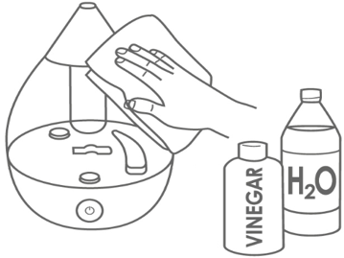
Step 1 Step 2 Step 3
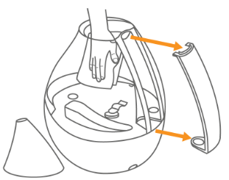
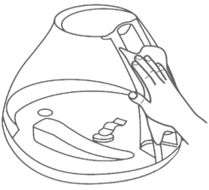

END-OF-SEASON MAINTENANCE & STORING YOUR HUMIDIFIER

- Turn off, unplug from outlet, and empty water from tank & humidifier base.
- Follow instructions for weekly cleaning above.
- Let all parts dry completely.
- Store humidifier in a cool, dry place

TROUBLESHOOTING
DO NOT attempt to repair the motor yourself.
If the humidifier continues to not operate, please contact Crane Customer Care.

Problem | Solution
Solid RED Indicator Light: | - Clean the Water Level Sensor Float: Pull the float from the base by lifting the float firmly. Remove the water level sensor float and clean with white vinegar/water solution. Replace water level sensor float by pressing down firmly back into position in the humidifier base. (Page 4 – Fig. 1 #5)
Humidifier Does Not Have Any Power: | - Ensure AC Adaptor is fully connected to the plug port and is properly plugged into a power outlet / try another power outlet.  - If Power On indicator light does not come on, contact Customer Care.
Flashing RED Indicator Light: | - The water level sensor float is not placed in the base and there is no water in the base.  - Ensure the water level sensor float is placed securely in the base and replace the full water tank onto the base.
Indicator Light is Green, But There’s No Mist: | - Complete the weekly cleaning. (Page 8)  - Humidifier should be placed on a hard-flat surface & fan vent should not be blocked.  - The humidifier base might be overfilled: Remove the tank, empty the base & replace the filled tank on the empty base.  - Ensure the water level sensor float is placed securely in the base.
White Dust Appears & Settles Outside the Humidifier: | - Area tap water may have too many minerals. Change to filtered or distilled water.
No Sound from icon | - Gently TAP the icon. Do NOT long press the icon
Humidifier is Leaking: | - From WATER TANK DISK/MIST NOZZLE: Turn mist level down.  - From TANK: Check for possible cracks in the tank or around the seam of the tank.  - From HUMIDIFIER BASE: Call Customer Care.

NOTE: Spare Parts can also be purchased online at www.cheekyrascals.co.uk

CUSTOMER CARE
CALL US: 01730 895761
EMAIL US: info@cheekyrascals.co.uk
WEBSITE: www.cheekyrascals.co.uk

CRANE WARRANTY

For more information regarding the warranty policy,
please visit our website:

L I M I T E D W A RR A N T Y

Thank you for purchasing a Crane product which has been tested to meet our stringent quality standards. This product is warrantied to be free from manufacturing defects under normal use and conditions for 1 year.

PLEASE CONTACT US BEFORE RETURNING THIS PRODUCT TO THE STORE.
CALL CRANE CUSTOMER CARE FOR PROBLEMS AND QUESTIONS. WE CAN HELP.

WARRANTY REQUIRES A DATED PROOF OF PURCHASE.

This warranty is void if the defect is due to accidental damage, misuse, abuse, neglect, improper repair or alteration by unauthorized persons, or a failure to follow operating instructions provided with the product including the use of essential oils directly into the tank and humidifier base. Only use the vapor pads in the aroma tray. This warranty does not apply to normal wear and tear or commercial use.

In no event shall liability exceed the purchase price paid by the purchaser of the product. Under no circumstances shall there be liability for any loss – direct, indirect or incidental – or consequential damage arising out of, or in connection with the use of this product.

This warranty is effective only if the product is purchased and operated in the United Kingdom.

Any instructions or warranty included in this manual may be subject to change without notice. For the most up-to-date instructions and warranty information, please contact us or visit our website.
TO RECEIVE WARRANTY INSTRUCTIONS AND RETURN AUTHORIZATION,

PLEASE CALL OR EMAIL CRANE CUSTOMER CARE.

Designed and Manufactured by
CRANE USA, INC.
1015 Hawthorn Dr., Itasca, IL 60143

Distributed by Cheeky Rascals
Liss Mill, Mill Road
Liss GU33 7BD UK

Phone Number: 01730 895761
(Monday - Friday 8:30am - 5:00pm)
Email: info@cheekyrascals.co.uk
Website: www.cheekyrascals.co.uk

